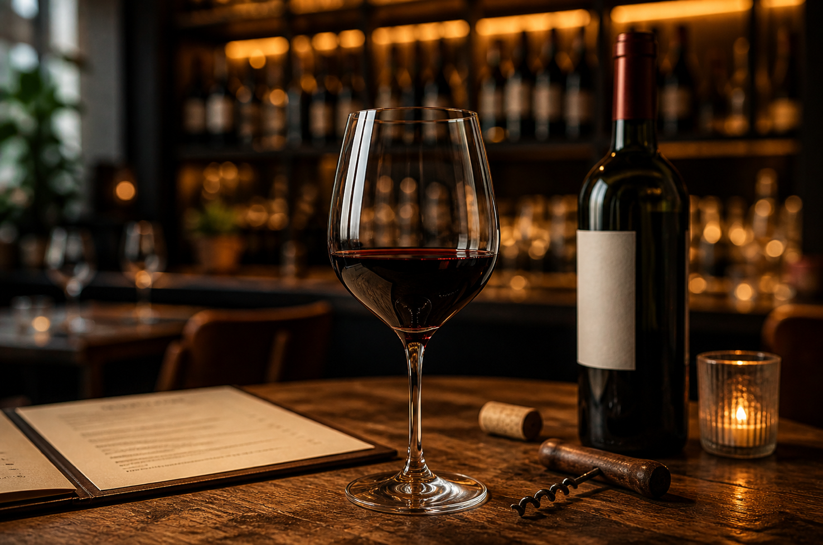

Stop Ordering Expensive Wine. Start Ordering Smart.
Most people think that the more they spend, the better the wine.
That’s not true.
After years working in high-end restaurants and managing wine programs, I can tell you one thing:
price is not quality — it’s positioning.
When you open a wine list, you’re not just looking at wine.
You’re looking at:
- branding
- margins
- psychology
That famous bottle everyone orders?
You’re often paying for the name, not the experience.
Take something like Caymus Cabernet Sauvignon.
Good wine? Yes.
Over-ordered? Also yes.
Here’s the truth most people don’t know:
The best value on a wine list is usually not the most expensive bottle
And it’s definitely not the cheapest one either
It’s the one in the middle…
or the one you’ve never heard of.
That’s where real quality hides:
- smaller producers
- less marketing
- more character
And this is where a good sommelier makes the difference.
A real professional is not there to sell you the highest price.
He’s there to guide you to the right bottle for your taste, your food, and your moment.
The problem is, most people don’t ask.
They play it safe.
They order what they recognize.
They miss the experience.
Next time you’re at a restaurant, do something different:
ask for a recommendation.
You might spend the same…
but drink something much better.

Don’t order to impress the table.
Order to enjoy the wine.

Follow for more real wine advice
No BS. Just experience.

